Introduction: The Basic Client Guide covers:

- Activating your ShareFile account
- Downloading files from a shared folder
- Uploading files to a shared folder
- Using Favorite folders
- Creating & Using Subfolders

1. Welcome to Wipfli ShareFile!

- Once a Wipfli Associate sets up your account, you will receive an email from ShareFile with a link to activate your user account.

Example of header of email:
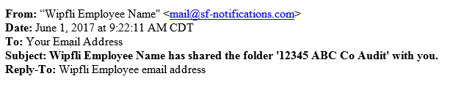

Example from Outlook of email:
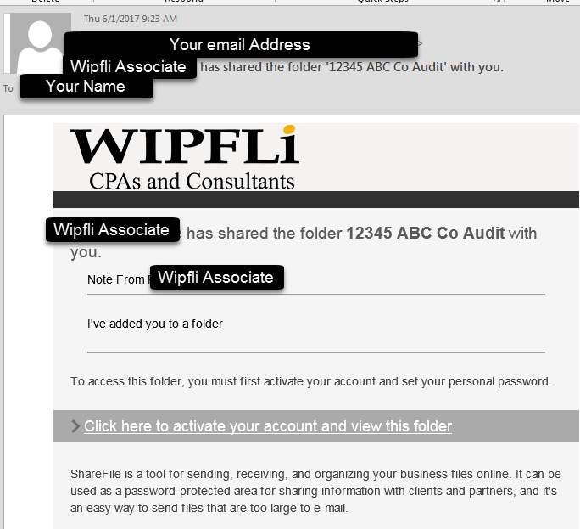

- Once your user account is activated, you will be able to access Wipfli ShareFile going forward by navigating your browser to www.wipfli.com, clicking on Client Portal and entering your credentials.

Note: If you have trouble receiving the activation email; please verify that the following email addresses are not blocked by your spam filter.
- *.sf-notifications.com
- mail@sf-notifications.com
- noreply@sf-notifications.com

ShareFile configuration information – Link

2. Downloading files

- Using the boxes next to files and folders in the ShareFile account, select the files and folders you wish to download and click Download. To download an individual file, you can also click the file name.
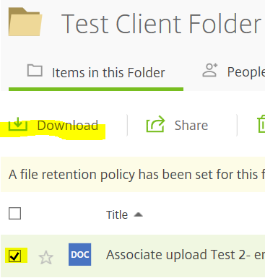

- Depending on your web browser, you may see the file name displayed on the bottom of your screen, or a pop-up will appear prompting you to save or open the file. Select to save or open the file.

- If you choose to open the file rather than save, you can save the file to your computer once it is open.

3. Uploading files

- Enter a folder by clicking its title on the Home screen.
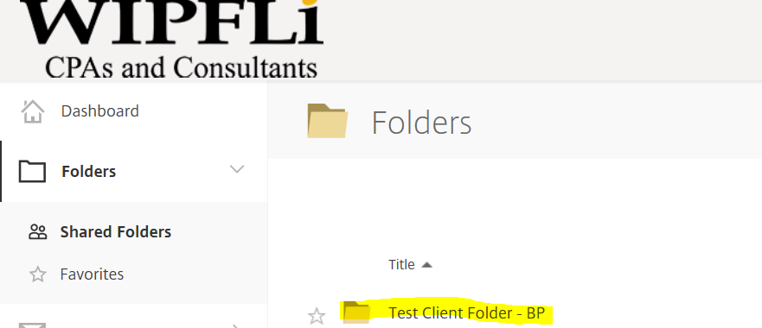

- Click Green + and then Click Upload Files.
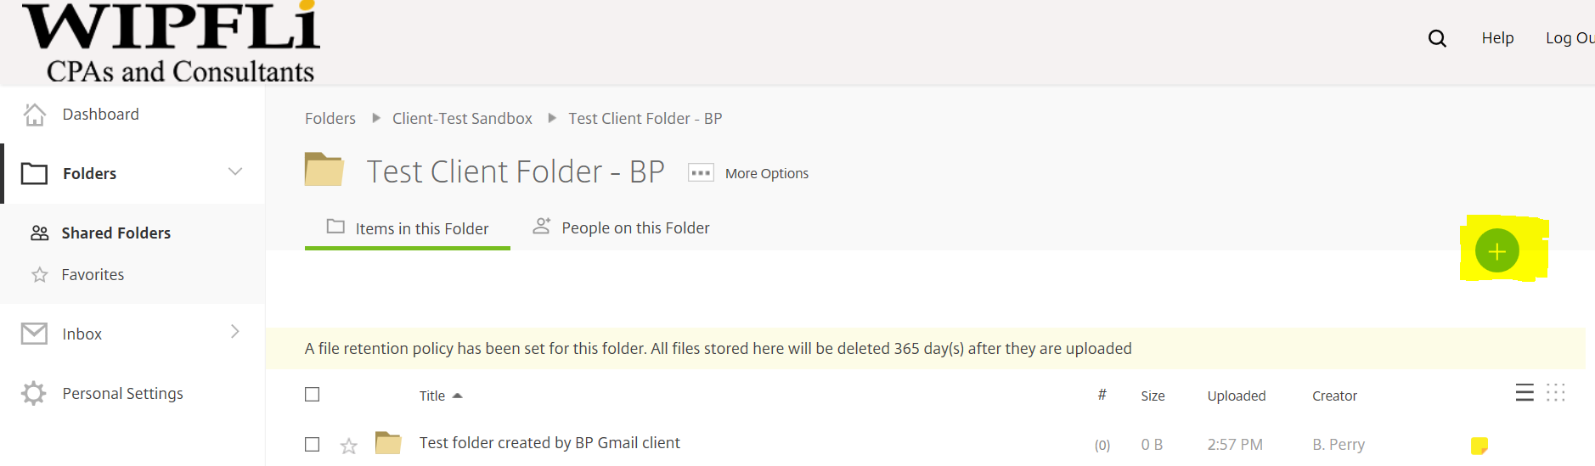

- Click Choose Files and then select the files from your computer that you would like to upload.

- Click Upload Files.

4. Favorite folders

In the Favorite Folders tab, click the star to the left of a folder to display it under your Favorite Folders tab. By selecting only the folders you use most to include in Favorite Folders, you can find and access these folders more easily.

You can remove a folder from the Favorite Folders tab at any time by clearing the star to the left of its name in either the Folders or Favorite Folders tab.
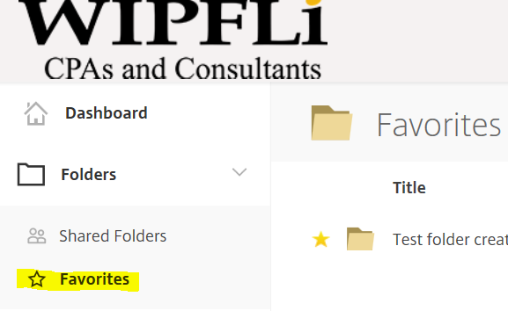

5. Creating and using subfolders

Creating: If you have upload permissions on a folder, you can also create a subfolder within that folder.

- Click Create Folder.

- Enter a folder title or name.

- Click Add Folder.

Using: It is suggested that we setup at least 2 folders inside each client folder.

- Folder 1 = Send to Wipfli

- Folder 2 = Send to Client

- This will help keep the back and forth cleaner and allow you to setup notifications on the subfolders as you see fit.

